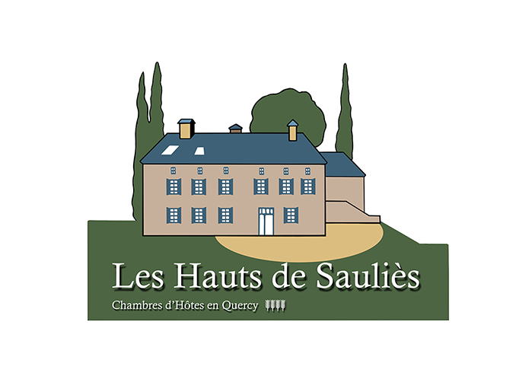

WELCOME TO SAULIES

The Lot department is rich in varied landscapes, delightful villages, historical sites, museums and vineyards.

Hiking beside our house or in the natural park of the Causses (GR46), Water sports on the Lot, ULM microlight and hot air balloon flights, visits to museums, wine cellars and historic and prehistoric sites and the most beautiful villages of France with Saint Cirq Lapopie.

Here are some essential activities:

- Cahors, medieval city with the Valentre Bridge (World Heritage of UNESCO) which is its emblem, St. Stephen's Cathedral with its Gothic cloister and tympanum, 2 weekly local markets (Wednesday and Saturday). You will also find the Museum of the Resistance.
- Saint Cirq Lapopie, village loved by André Breton, and voted the prettiest village in France in 2012, hanging on a cliff overlooking nearly 100m the banks of the Lot with its restored old houses, its castle, its streets paved, its shops, crafts, its art galleries and restaurants. We advise you to arrive mid-morning to avoid high temperatures during the climb to the village. There are several paying car park (card or cash € 3); including one down the village and another over the village.
You can also drop off your car in Bouzies, take the towpath to St Cirq Lapopie
The hike is 4kms: http://www.lanoque.com/article-de-bouzies-a-saint-cirq-lapopie-par-le-chemin-de-halage-112201001.html

The other most beautiful villages of France: Autoire, Carennac, Loubressac, Cardaillac.
- The Prehistoric Cave of Pech'Merle, On the way to Saint Cirq Lapopie, this prehistoric cave will surprise you with the quality of the rock paintings.
There is also the Padirac to visit and Lacave caves.

- A trip by barge on the Lot starting from Bouzies with arrival at the foot of St. Cirq Lapopie.
You can see an old towpath carved into the rock and carved by an artist, a 2 manual locks boat, an old water mill while listening to a historical narrative of the river traffic on the Lot. You can book your tickets by internet. There is also such a trip from Cahors.
- Kayaking or canoeing or canyoning, caving, climbing with Kalapca.
- Visit the museum Zadkine to Arques. Opposite the museum there is a Roman church to visit.
- Rocamadour, important site of Christianity, with its church and its virgin "Black". We advise you to arrive via L'Hospitalet. You'll have a wonderful view of the village down to Rocamandour.
- Visit the Castle of Cenevieres. Castle beautifully restored with beautiful wood ceiling in the dining room and an alchemy room. The visit by the Dean of the castle is worth a detour. It is a colourful character.
Also visit the castle of Bonaguil and Castelneau Bretonoux
- Figeac, known thanks to Champollion who deciphered Egyptian hieroglyphics. Figeac offers a unique collection of medieval houses.
- Walking in the regional park of Causses by bike or car. Enjoy the beautiful landscapes, views in the distant horizon with its small villages, some of which are dry stone constructions. http://www.parc-causses-du-quercy.fr
- Discover the vineyards of Cahors with its AOC wines and vineyards. We will advise you some cellars from who we buy our wine.
- Enjoy the cadurcienne food; its duck, foie gras, truffles, gourmet and starred restaurants. We can recommend restaurants we frequent.
- Fishing in the River Lot. http://www.pechelot.com/web/

